**ASSIGNMENT-1(YASHWANT,B18)**

1.Power bi installation

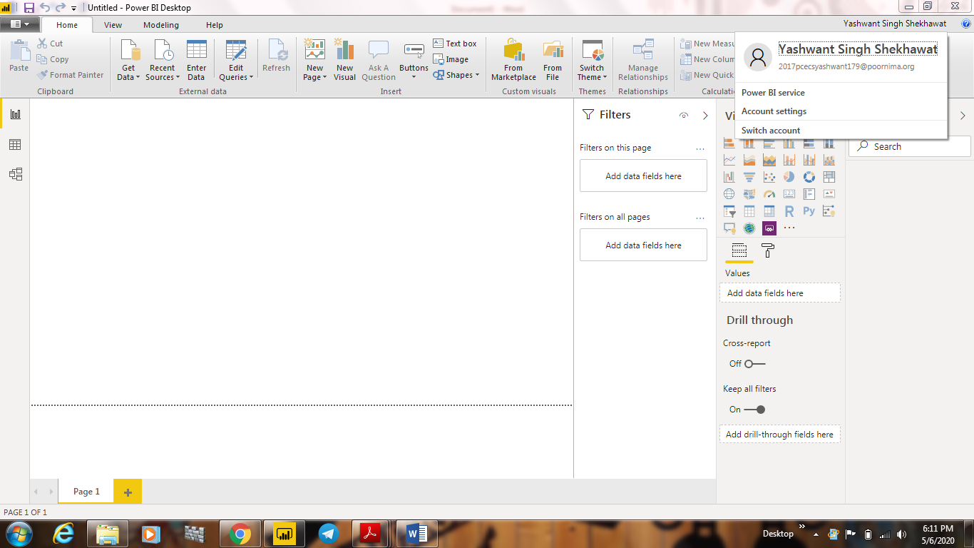

2(i).Report view

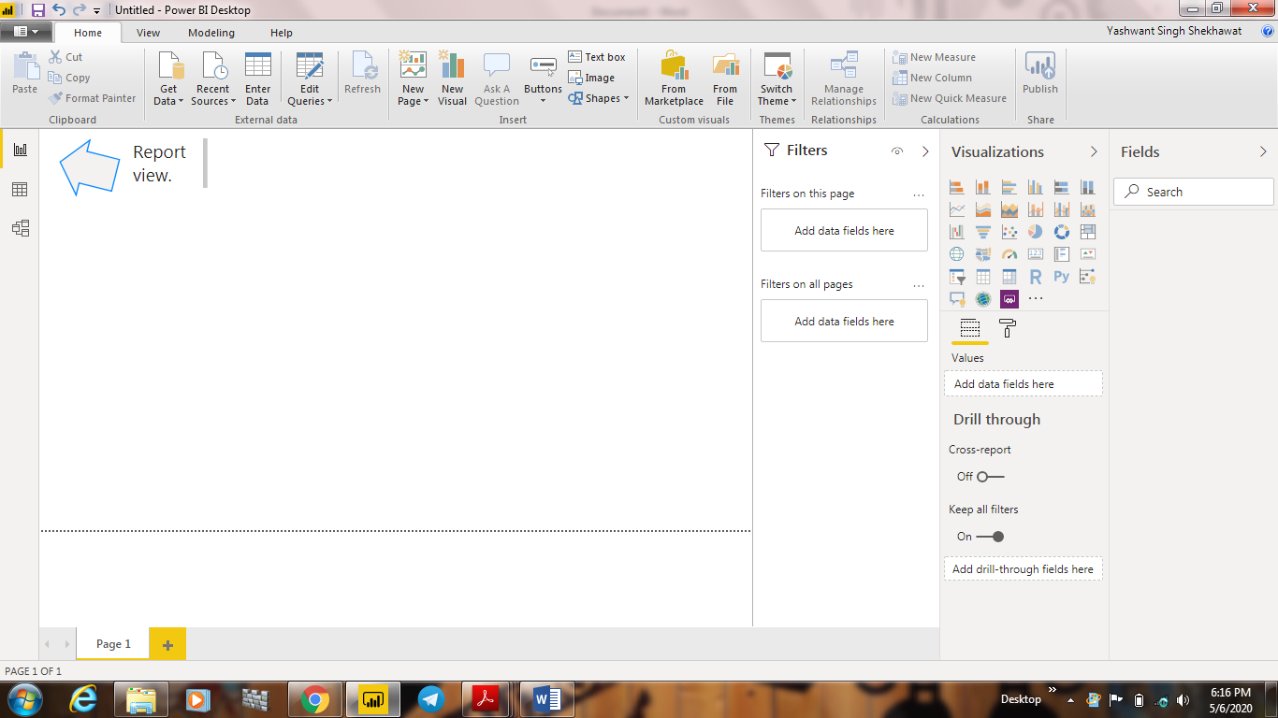

2(ii).Data view



2(iii).Model View

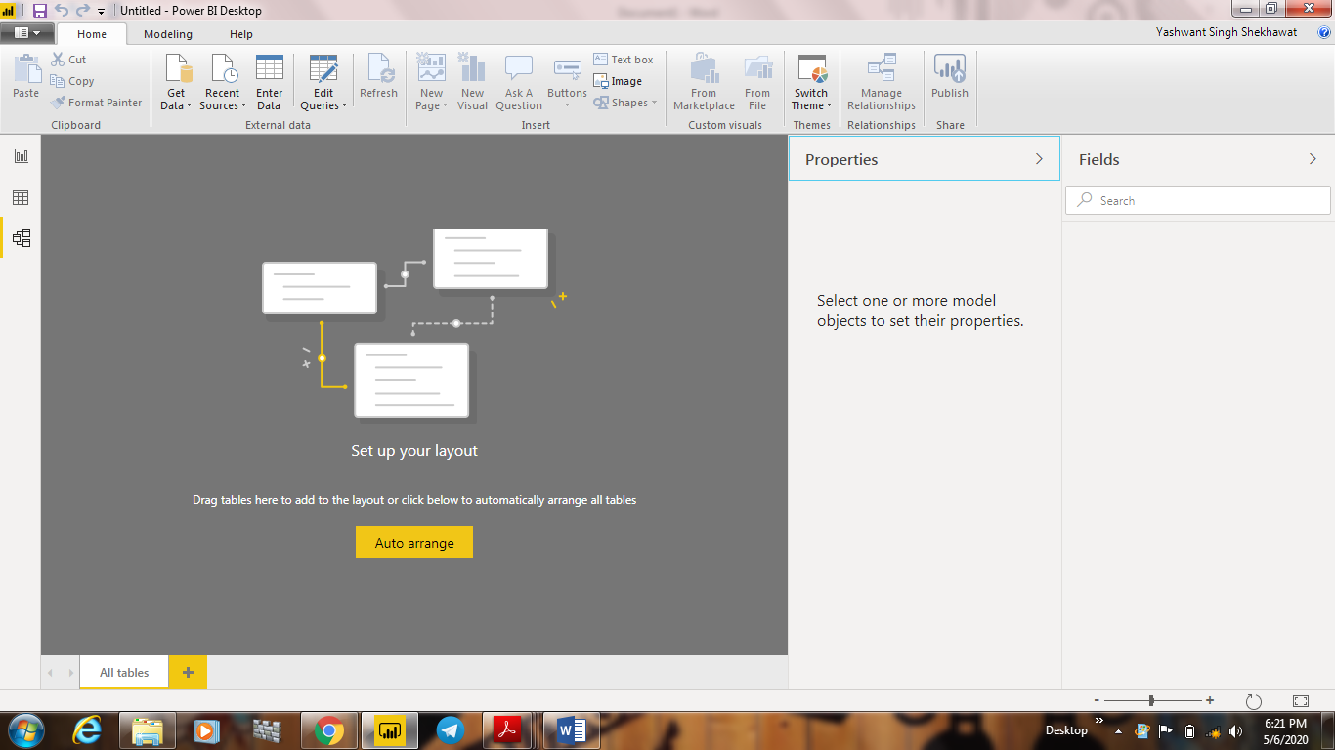

2(iv)Power query editor



2(v)Advance editor

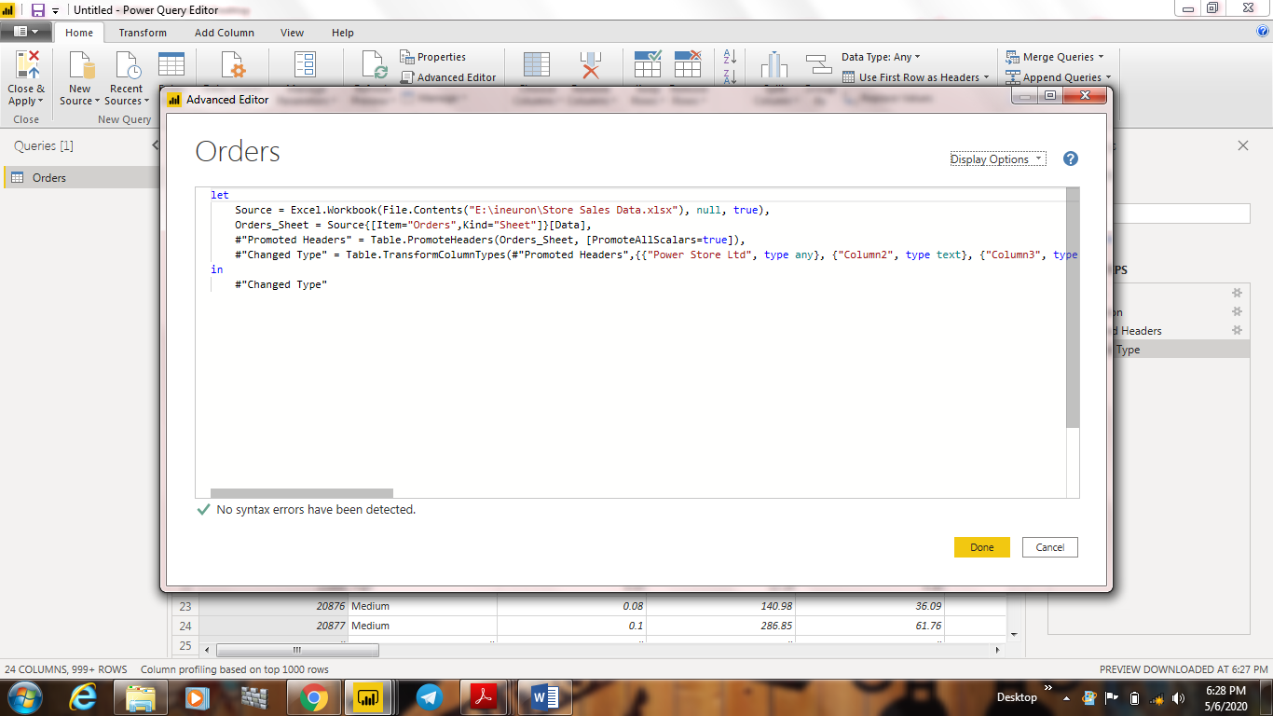

3.Prices of diiferent versions of power bi:-

(i)Power BI desktop-FREE FOR LIFETIME.

(ii) Power BI PRO-$9.99/month.

(iii) Power BI Premium-$4995/month.